to fall off = to depart

to get rid of fuel = to dump fuel / to jettison fuel

smoke trail = fumes

they are leaving smoke trails behind

they are giving off the fumes

smoke trail after / behind them

*before/after = time reference only

it's blurry
I can't make the markings OUT
I can't recognize them from the distance

biplane

an air-show routine
a vintage biplane
relatively close to each other
slightly (lower)
they are giving off display smoke trails
the exhaust
performing this aerobatic manoeuver

(in)sufficient acknowledgement

rock your wings if there's not enough time for verbal responses

LEFT-HAND TRAFFIC PATTERN (CIRCUIT)
Consists of (how many) legs?
What are they?

5

departure
crosswind
downwind
base
final

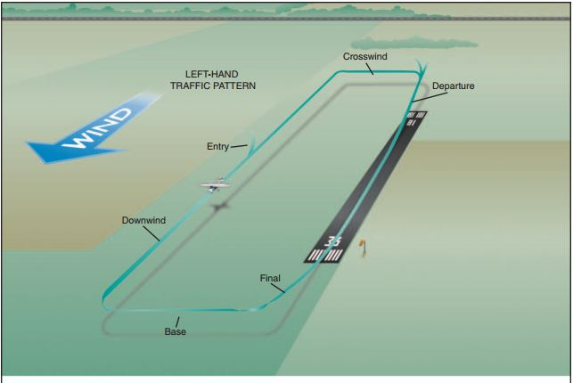

I can see a blue and white high-wing east of Benejov.

Keep your gear up until west of Benejov.

Turn left and get in line behind the Ikarus.

You’ve flown away from the railway tracks.

The Staggerwing up ahead is going to be too slow for you.

